**D:\Users\Corbell\AppData\Local\Microsoft\Windows\Temporary Internet Files\Content.IE5\LUIHZFL2\MC900390954[1].wmf Boomerang Lunch Program**

Dear Parents,

At St. Marguerite Bourgeoys we have adopted a Boomerang Lunch program to help us make a difference in our environment. The boomerang lunch program focuses on important objectives! We hope to reduce waste and encourage students and families to review and rethink about the way they prepare and package lunch and snack foods.

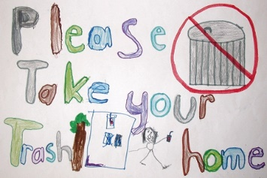**HOW IT WORKS**

All pre-packaged waste from your child’s lunches and snacks will be returned home in their lunch bags. This includes any packaging, plastic bags and wrapping. Any compostable items such as fruit peelings and uneaten crusts of sandwiches will be composted as part of our school’s green bin program.

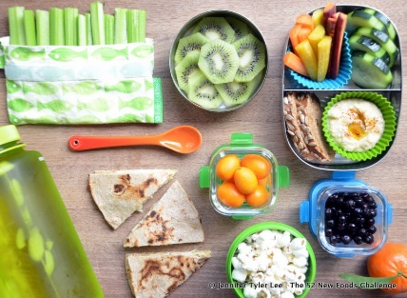**WHY BOOMERANG LUNCHES?**

It’s the right thing to do for our environment! Most of the lunch waste in our school comes from disposable packaging of single use food items, such as plastic bags, yogurt cups, and juice boxes According to data from the [Recycling Council of Ontario](https://www.rco.on.ca/waste-free_lunch_challenge), the average student’s lunch can generate 30 kg of waste over the course of a school year. That’s roughly 66 pounds of garbage, per kid! Although some of this waste is made of recyclable materials, it is still a huge cost to transport, and process these items. We teach our students that reducing waste is the number one choice when looking at the four “R’s”. The fourth “R” is to re-think what choices we make. Encouraging the use of re-usable containers and bringing the right amount of food will reinforce that children can be part of the solution to our waste problems.

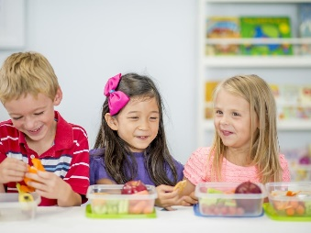**Boomerang lunches enable parents to see what their children are actually eating during the day.**

A boomerang lunch also provides parents with firsthand knowledge of the eating habits and preferences of their child. By bringing home the leftovers you will see what’s been eaten or not. Teachers see a huge amount of uneaten food go into the garbage day after day. This is not only wasteful, but expensive.

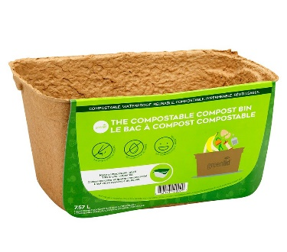**St. Marguerite Bourgeoys Catholic School has the compost bin program to support boomerang lunches.**

One of the main concerns parents have expressed with the boomerang lunch program is that their child will return home with a messy lunch bag. By collecting banana peels, apple cores and other compostable items as part of our compost program, there should be no need for anything messy to be returned home. All other items can be placed in sealed reusable containers.

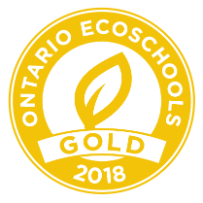

**Boomerang lunches work!**

St. Marguerite prides itself in being a leader in the way we treat the Earth. We currently hold a gold level Eco-school status as part of the Ontario Eco-schools program. The boomerang lunch program is another

area we can show our respect for our environment. Many schools

throughout the Kingston Region and other school boards have

implemented boomerang lunches with tremendous success.

We know this program will require families to re-think food preparation and student actions. Our hope is that informative discussions will take place at home and school and habits will change. Packing a waste-free lunch not only helps the environment, it can also result in healthier, more nutritious snack/lunches as many packaged foods contain significant amounts of salt, preservatives, sugar, and fat. There is also a cost savings as lunches made of packaged items cost significantly more than buying large quantities and serving them in re-useable containers.

Thanks for your support with very important initiative,

St. Marguerite’s Eco-team

D:\Users\Corbell\AppData\Local\Microsoft\Windows\Temporary Internet Files\Content.IE5\QYQRU5WW\MC900060285[1].wmf

**Boomerang Lunch – Frequently Asked Questions**

***What can I do to ensure my child doesn’t come home with a messy lunch bag?***

The number one choice is to send all food items in sealable reusable containers and to promote the use of the classroom compost bins for waste food. Therefore, the only items returning in the lunch bag will be in sealed containers ready to be washed and used the next day. If you choose to send disposable containers such as yogurt, apple sauce, and juice boxes, your child will be encouraged to place the empty containers in a re-sealable bag to be returned home

***Isn’t waste just being diverted home and then thrown in the garbage?***

The eco-team feels that it is our responsibility to teach the students the number one best option for our environment. This is ***reducing*** waste. The purpose of the boomerang program is to promote the use of reusable containers, thus reducing the amount of lunch waste being produced by our school. The collection, transportation, and processing of garbage as well as recyclable materials requires a significant amount of energy, putting strain on our environment.

**Boomerang Lunch Tips**

**BULK UP!**

Choose to buy food that is not over-packaged by buying items in bulk rather than single use containers and placing them daily in re-sealable containers. Example – buy the large yogurt containers and put it into a re-sealable container.

**LET NATURE WRAP YOUR FOOD FOR YOU!**

Oranges, bananas, apples and hard-boiled eggs all come with their own handy packaging. Their packaging can be composted as part of school compost program

**CHOOSE A PERMANENT PACKAGING SOLUTION**

Pack a waste-free lunch using items such as:

- reusable lunch bag or box (look for a hard plastic interior, as it can easily be wiped clean)

- thermoses

- reusable water bottles

- reusable plastic containers

- cloth napkins

- reusable utensils

**AVOID THE FEROCIOUS FIVE WEAPONS OF WASTE!**

1. plastic: single use sandwich bags, plastic wrap, utensils

2. single serving yogurt, pudding, apple sauce cups

3. drink boxes, drink pouches, pop cans

4. throw away paper bags

5. aluminum foil